╛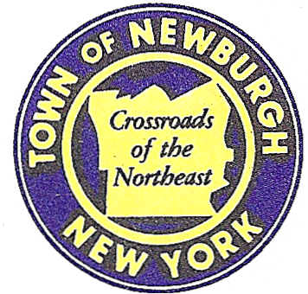

TOWN OF NEWBURGH
_______Crossroads of the Northeast __________________________
OLD TOWN HALL
308 GARDNERTOWN ROAD NEWBURGH, NEW YORK 12550

PLANNING BOARD
JOHN P. EWASUTYN, CHAIRMAN
TELEPHONE 845-564-7804
FAX 845-564-7802
E-MAIL: planningboard@townofnewburgh.org

PLANNING BOARD AGENDA

March 21, 2019

*PLEASE NOTE: The Planning Board Meeting will start at 7:00 P.M. and all Applicants/Representatives
are to be present at that time. The Meeting will be held in the Meeting Room of Town Hall,
located at 1496 Route 300, Newburgh NY.*

- 11 Old Balmville Road, LLC (18-18) PUBLIC HEARING
11 Old Balmville Road
Section 84, Block 5, Lot 26
Zone: 04
Rep: Pitingaro & Doetsch Consulting Engineers, PC/Jason Pitingaro
15 Industrial Drive, Suite 2
Middletown, NY 10941

- A. Duie Pyle Maintenance Building (19-09) INITIAL APPEARANCE
1000 Corporate Blvd. LOT LINE CHANGE
Section 95, Block 1 Lot 69.1
Section 95, Block 1 Lot 79
Zone: IB
Rep: Langan Engineering /Justin Macalintal
707 Westchester Ave. Suite 304
White Plains, NY 10604-3102

- BJ’S Wholesale Club- Newburgh(19-07) INITIAL APPEARANCE
NYS Route 17K & Auto Park Place SITE PLAN
Section 97, Block 2, Lot 44,46.2 & 45
Zone: IB
Rep: Maser Consulting, P.A.
555 Hudson Valley Ave. Suite 101
New Windsor, NY 12553

*WORK SESSION*
Project Readiness Discussion scheduled for 5:30 p.m. in the Meeting Room of
Town Hall on Thursday, March 21st, 2019.*

PLANNING BOARD BUSINESS
WORK SESSION

- Elm Farm Subdivision- ( 2000-09): Requesting an extension from March 21,
2019 to an undetermined date.

*WORK SESSION*
Project Readiness Discussion scheduled for 5:30 p.m. in the Meeting Room of
Town Hall on Thursday, March 21st, 2019.*

